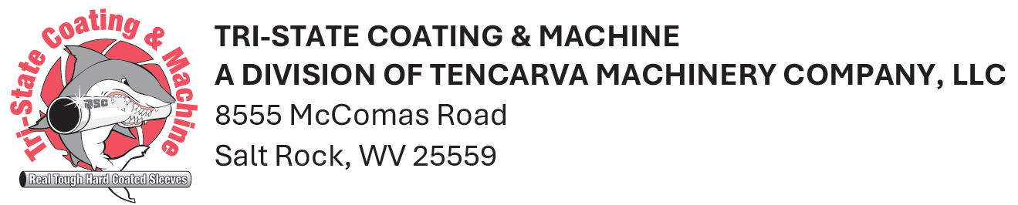
Wednesday, May 8, 2024

Dear Valued Supplier,
We are excited to announce that as of May 8th, 2024, Tri-State Coating & Machine was acquired by Tencarva Machinery Company, LLC. Tri-State Coating & Machine will still operate under their same trusted name and function as a division of Tencarva Machinery Company, LLC. As a supplier, you can expect the same commitment to positive supplier relationships and on-time payments that you have come to know and trust with Tri-State.
Tencarva is an employee-owned industrial distributor headquartered in Greensboro, NC, with 510 employees in 32 branches across 14 states. Tencarva contributes a major part of our success to premium suppliers like you. Our hope is that this will be a seamless transition. However, if you have any questions or need assistance our team is here to help.
Attached are the following documents for your review. Please feel free to reach out with questions or concerns.
- Attachments
  - Tencarva credit references
  - Tencarva tax exemption certificates
- Transition Information and FAQ’s
  - Purchase orders from (unchanged):
    - Tri-State Coatings & Machine
  - Invoices are mailed to (unchanged):
    - Tri-State Coating & Machine, PO Box 296, Salt Rock, WV 25559
  - AP Contact
    - Ginger Parsons
      - Phone: 304-948-1272
      - Email: gparsons@tscminc.com

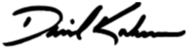
Sincerely,

David Kirkman
Shared Services Accounting Manager
dkirkman@tencarva.com
336-554-8514

